EASE Multi-Instance Scripts

The latest series of scripts have been modified in two ways.

1. We expanded the number of scripts be de-bundling multiple EASE Jobs in one script. We are also providing the bundled scripts including “BUNDLE” in the name. This allows the client to decide. The bundled scripts are quicker to setup but take more work to maintain.
2. We added a Command line parameter **-Identifier** which will be used by each workflow to keep each instance from stepping on each other’s toes. This Identifier will be used to name each Multi-Instance Job as well as the SI.SEQ which gets created.
   1. Example: if my Identifier is ACHPOST then the RSJ Job will be named RSJ_ACHPOST and the SI.SEQ will be named SI.SEQ_ACHPOST.

# Updates to Jobs at within EASE’s OpCon environment

We decided to separate the single threaded and multi-threaded Schedules. For simplicity, copy the single threaded Schedule to create the multi-threaded Schedule. All the Jobs will have the same name except for **RSJ** which needs to be copied creating **RSJMULTI**. The only difference between the two is the Resource Dependency they will have. All Jobs need to be updated to Allow Multi-Instance.

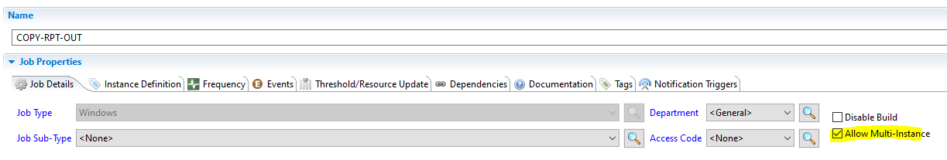

Another change is anywhere the [[SI.SEQ]] is used will need to be updated with:

[[SI.[[="SEQ-"+[[JI.IDENTIFIER]]]]]]

This allows the multi-instance Job to point to the correct Schedule Instance Property which is created using the Identifier parameter.

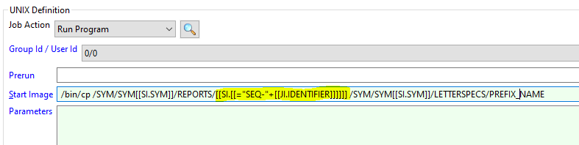

The SEQ Job will need to add the [[JI.IDENTIFIER]]. The EASE Connector script will remove all special characters from the IDENTIFIER to avoid event syntax errors.

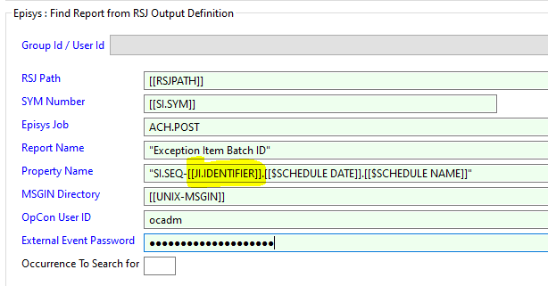

Lastly, Resources need to be added to throttle multiple items.

* **RSJMULTI** needs to have a Resource Dependencies with on a Resource with a Max Value of 3 (or whatever you all decide to allow as the max concurrent processes)
* **RSJ** needs to have a Resource Dependencies with on a Resource with a Max Value of 1.
* **RUN-FTP-OUT** needs to have a Resource Dependencies with on a Resource with a Max Value of 1.
* **RSJEDIT** needs to have a Resource Dependencies with on a Resource with a Max Value of 1.

# Updates for the Clients

This changes things for the way the clients set process up more than it changes things for EASE. A few of the changes are:

* They will need to duplicate their EASE-CONNECTION Global Property because they will have a new Schedule Name.
* The scripts are named a little differently because of the breakup of the bundles.
  + They can keep their current names and just copy the contents of the scripts into the embedded script.
* There is also a new -Identifier command line parameter which needs to be added to each Job. This is critical to make sure each workflow running concurrently does not step on each other’s toes. The Identifier name must be unique.

## Script Names and brief Description

* **EASE-MULTI-BUNDLE-RSJEDIT.ps1** – this script runs two EASE Jobs. The Edit Job is single threaded, but the Identifier parameter is still necessary to make sure it does not collide with other processes running around the same time.
  + **MONITOR**
  + **RSJEDIT**
  + The script will be run right after the Credit Union FTP’s a file to Jack Henry’s DMZ. The Monitor Job will be initiated to verify once the file has relayed all the way to the Symitar server. Then the RSJEDIT job is run.
* **EASE-MULTI-BUNDLE-SEQ-FTP.ps1** – this script runs three EASE Jobs.
  + **SEQ**
  + **COPY-RPT-OUT**
  + **RUN-FTP-OUT**
  + This script will be run when a Credit Union is ready to find and FTP a report off Symitar. It starts by launching the SEQ Job collecting sequence number of the report. Then it copies that file from REPORTS to LETTERSPECS using the required naming convention. Lastly it runs the MoveIT API Job which will transfer the file to a location the Credit Union can access.
* **EASE-MULTI-BUNDLE-SEQ-PROMPT.ps1** – this script runs two EASE Jobs.
  + **SEQ**
  + **PROMPTSEQ**
  + This script will be used when the client needs to collect a collect the sequence number of a report and then use it to answer prompts before running an RSJ Job.
* **EASE-MULTI-LETTERFILE-COPY.ps1** – This script runs the **COPY-RPT-OUT** EASE Job.
* **EASE-MULTI-LETTERFILE-COPY-OR-RENAME.ps1** – This script runs either the **COPY--LTRFILE-OUT** or the **RENAME-LTRFILE-OUT EASE** Job.
* **EASE-MULTI-LETTERFILE-FTP-ONLY.ps1** – This script runs the **RUN-FTP-OUT** EASE Job.
* **EASE-MULTI-LETTERFILE-RENAME.ps1** – This script runs the **RENAME-LTRFILE-IN** EASE Job.
* **EASE-MULTI-MONITOR.ps1** – This script runs the **MONITOR** EASE Job.
* **EASE-MULTI-PROMPT.ps1** – This script runs the **PROMPT** EASE Job.
* **EASE-MULTI-PROMPT-SEQ.ps1** – This script runs the **PROMPTSEQ** EASE Job.
* **EASE-MULTI-RESET.ps1** – This script runs the **RESET** EASE Job.
* **EASE-MULTI-RSJ.ps1** – This script runs the **RSJ** EASE Job. This version of the RSJ Job will be single threaded by being tied to a resource with a max value of 1.
* **EASE-MULTI-RSJEDIT.ps1** – This script runs the **RSJEDIT** EASE Job.
* **EASE-MULTI-RSJ-MULTI.ps1** – This script runs the **RSJMULTI** EASE Job. This version of the RSJ Job will be multi-threaded by a Resource with a max value of 3.
* **EASE-MULTI-SEQ.ps1** – This script runs the **SEQ** EASE Job.